**INTB,**

**Tamim Tumi**

**Yung Chong**

**Databases For Business**

**Mr. Stephan White**

Introduction of “Sushida Tokyo Restaurant”

Sushi Tokyo is a Sushi restaurant in Dún Laoghaire. Dún Laoghaire beautiful location, close to other beautiful coastal locations, and great shopping and places to eat.

The location of a restaurant is crucial to the operation of a catering business, in many cases, the location of a restaurant often determines the success or failure of a restaurant. We have chosen Dún Laoghaire, Dún Laoghaire is a town in Ireland that is known for its affluent residential areas and stunning coastline. It is considered to be a prosperous area but not all parts of the town may be considered” prosperous”. According to the Central Statistics Office of Ireland, the population of Dún Laoghaire -Rathdown, which includes the town of Dún Laoghaire, was 218,018 as of the 2016 census.

# Food Acceptance and Satisfaction

The food acceptance of Irish people is highly diverse, but it has evolved significantly in recent years. In recent years, there has been a growing emphasis on healthy eating in Ireland, with a focus on fresh fruits and vegetables, especially organic and locally sourced foods are also becoming increasingly popular. Such as sashimi, vegetables, and seaweed which we sell at our restaurant Sushida Tokyo. These ingredients are not only nutritious but also rich in both proteins and vitamins, which are very beneficial to human health.

Ireland is located on the east coast of the Atlantic Ocean, such as seafood is an integral part of the country’s diet. Lobster, crab, and a variety of fish are common ingredients in the Irish diet. We have high standards for quality and attention to detail, which often results in a high level of customer satisfaction.

In Sushida Tokyo, the sushi chef puts the finished pieces on a conveyor belt behind a plate that runs around the dining room table. In addition to Japanese cuisine, our restaurant includes meat dishes such as beef steak and Sukiyaki, seafood dishes such as sashimi, and French and Italian cuisine. Our restaurant uses safe and well-selected seasonal ingredients from all over Japan to fully enjoy the delicious taste of Japan. In addition to tasting the delicious food, you can also experience the Japanese way of hospitality and appreciate the beautiful tableware on which the food is served and the lovely environment with painted walls, art, and beautiful décor.

**Japanese Hospitality in Sushida Tokyo Restaurant:**

At Sushida Tokyo Restaurant, we treat our customers with respect and politeness. Our waitstaff is trained to greet customers with a bow and use honorific language to show our kindness and deference. Because Japanese hospitality is deeply rooted in the culture. We also provide excellent service, the waitstaff is trained to keep an eye on customers and refill their drinks, and clear their plates without being asked.

**Entity Relationship Diagram:**

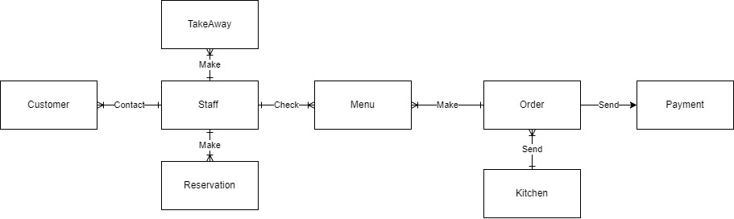

1. **Customer**

|  |  |
| --- | --- |
| CustomerID | PK |
| Firstname | Short text (10) |
| Surname | Short text (10) |
| Phone-number | Short text (15) |
| Email | Short text (15) |

**CustomerID:** It is important to assign a unique customer ID to each customer, it helps our restaurant to track our customers’ behaviours, and consumption history.

**First name & Surname**: The reservation name is important in our reservation system because it can help our restaurant confirm the reservation person's identity to ensure the reservation's accuracy and validity. It also helps our staff better understand customers’ needs and preferences.

**Phone number**: The phone number helps our restaurant to confirm the identity of the person who made the reservation and update the status. Otherwise, our staff needs to contact the customers to confirm the reservation and remind the of the reservation.

**Email:** Email is also significant for customers when they make a restaurant reservation. Our restaurant can also use email to promote breakfast, lunch, and dinner specials to consumers. Email can transmit more information, and it can be easily saved, retrieved, and shared by customers. This is especially helpful when promoting event sign-ups or limited time offers.

1. **Reservation**

There are many ways to make reservations at our restaurant.

1. Online reservation service- With the popularity of the internet, our restaurant also offers an online reservation service. Customers can make their reservations through our website which is [www.sushidatokyorestaurant.ie](http://www.sushidatokyorestaurant.ie). Customers also can make the reservations on their mobile phone or computer at any time. Through our online reservation system, customers can know the reservation status of our restaurant in real-time and choose their own mealtime.
2. Phone call reservation-Customers can also use the restaurant’s official website, social media, or search engines such as Google or Google Maps to find our restaurant’s phone number. Please inform our staff of the time and number of people they want to book a meal. Our staff will check if there is a table available and customers should provide their contact information so that our staff can contact the customers when needed.
3. In-store reservation: If customers are not convenient make a reservation by phone or the internet. Customers are freely making their reservations directly in our restaurant.

Data that Sushida Tokyo restaurant needs to collect from customers.

* Time of arrival
* Number of people
* ReservationID

|  |  |
| --- | --- |
| ReservationID | PK |
| CustomerID | FK |
| No-of-people | number |
| Table | number |
| Date of Arrival | Date/Time |
| Time of Arrival | Date/Time |

**ReservationID**: The reservationID helps to reduce confusion regarding the reservation details.

**Date-Time**: It records the Date and time that the customers will come to our restaurant.

**No-of-people**: Based on the no of people, our staff can easily determine how many seats need to be prepared for customers. If a larger group of customers, staff may require preparing more food and beverages stock. It is an important factor in our reservation system.

**Table:** we will set customers into tables, depending on how many people they have and will have the number of the table to easily send items to that table while keeping track of availabilities.

**Date of Arrival & Time of Arrival:** The Day the customer would like to come, and then the time that they would like to come, so we can know roughly when the person will come so we can prepare the tables beforehand.

1. **Take Away**

Our restaurant has a takeaway service, which quick and convenient way to order food for people who are lazy to cook.

If customers want to order takeout, they can do it in the following ways:

1. Order online: Our restaurant has an official website, and it provides the option to order online. Customers can simply select the food and drinks they want.
2. Third-party platform: Deliveroo or Just eat, food delivery platforms are gaining popularity because the demand for convenience and speed continues to increase.
3. collection: If customers want to pick up their order, they can go directly to our restaurant and pick up their order without having to wait for a deliveryman to deliver it because there is usually no extra delivery charge.

Data that Sushida Tokyo restaurant needs to collect from customers.

* TakeawayID
* Address (If needed)
* Payment
* CustomerID

|  |  |
| --- | --- |
| TakeawayID | PK |
| Address | Long text (30) |
| CustomerID | FK |
| Date of Takeaway | Date/Time |
| Time of Takeaway | Date/Time |

**TakeAwayID:** TakeawayID to help ease confusion of the different takeaway ways, instead of having to look for the name on the different devices and databases, the TakeawayID is much easier to look for and less confusing.

**Address:** Address is important in our delivery service because, without a clear and accurate address, it is difficult for the delivery man. Clear and accurate it helps to optimize the delivery operation.

Date of Takeaway & Time of Takeaway: This is to keep tracking of the takeaway orders and when the person set the order, so we can do the orders in a timely fashion, and not get confused by past ones.

1. **Staff**

Different positions perform specific functions in the restaurant. The staff is the key component of our restaurant. Waiters/Waitresses will encounter a variety of guests every day, and the problems encountered must also be different. Next, I will introduce you to the catering waiter job duties, I hope that the catering waiter can help.

The staff will provide a dining experience for customers, The waiter or waitress needs to know the knowledge about the menu, be attentive to customers' needs, and be able to handle any complaints.

1. Welcome and assist guests to be seated.
2. Assist customers to order food and drinks.
3. Make sure the customer's food and drink orders are correct and check them.
4. Enter orders into the computer according to restaurant operation procedures and inform the kitchen in a timely manner.
5. Maintain the cleanliness and hygiene of the restaurant.

|  |  |
| --- | --- |
| StaffID | PK |
| Firstname | Short text (10) |
| Surname | Short text (10) |
| Job-Role | Short text (10) |
| PhoneNumber | Short text (20) |
| PPSN | Short text (15) |
| Address | Long text (20) |
| Email | Long text (20) |
| Schedule | Date/Time |

StaffID: The staffID helps our restaurant to keep detailed records of an employee’s employment history, so that we can easily manage employees’ information.

FirstName & Surname: It helps us have a clear and accurate name on our record so that we can manage employees’ payroll or benefits.

Job-Role: It’s to show a job position and a specific set of responsibilities.

PhoneNumber: The PhoneNumber helps our restaurant contact employees with work-related matters or emergencies.

PPSN: PPSN stands for Personal Public Service Number, it helps our restaurant to declare their tax information.

Email: The email helps our restaurant to send a payslip record to employees.

Address: It helps to communicate with employees, for example, the legal compliance purpose, etc.

Schedule: The schedule helps our restaurant to track employee hours so that we can manage the payroll.

1. **Menu**

|  |  |
| --- | --- |
| MenuID | PK |
| Foodname | ShortText(20) |
| Price | Currency |

The Menu Table, we will have a list of the Menu Items and the prices for all of our food and drinks at Sushida Tokyo Restaurant. Our menu is carefully made to provide the customer with a wide variety of authentic and traditional Japanese dishes, prepared with the freshest and finest ingredients and traditional cooking methods.

MenuID: MenuID helps our restaurant to give different foods and items a unique MenuID, so they can be linked without any issues to the customer’s orders.

FoodName: FoodName is an important component of MenuID,it helps to search for a specific dish or ingredient and it helps maintain consistency across different menus.

Price: Used in the menu database so that we can charge the customers the correct amount of their order and to show the customers how much do items cost.

1. **Order**

|  |  |
| --- | --- |
| OrderID | PK |
| CustomerID | FK |
| FoodnameID | ShortText(20) [From Menu] |
| Quantity | Number |
| TotalPrice | Currency |

The Order Table will be set after the Menu Table, The OrderID will be created and match the FK of CustomerID, the foodname, quantity for the kitchen, and the TotalPrice which will be used later for the payment table, which will be Quantity [Order Table] X Price [Menu Table] = TotalPrice

OrderID: The OrderID can help our restaurant to track the customer’s order and if the customer has any problem with their order, we can quickly track their order to fulfil them in a timely and efficient service.

TotalPrice: The TotalPrice helps us to reduce misunderstandings with orders and it helps to prevent errors and inaccuracies in transactions.

1. **Kitchen**

The chef is the soul of a restaurant. The reason is simple, customers to the restaurant is to "eat", so even if the restaurant has a good location, good decoration, good management, and good service, if there are no good chef-cooked dishes that customers like, then it is difficult to make customers like your restaurant. In the Sushi restaurant, the role of the Sushi chef is very important, they grasp the taste and quality of the dishes produced in the restaurant, a restaurant has an excellent chef, there will be a minimum guarantee of success.

1. The chef needs to grasp the food supply situation, timely order, and replenishment.
2. Maintain contact with service staff to continuously improve and enhance the quality of food produced from the kitchen.
3. The chef needs to control food costs and determine whether the ingredients are good.

|  |  |
| --- | --- |
| KitchenID | PK |
| OrderID | FK |
| CustomerID | FK |
| FoodName | ShortText(20) |
| Quantity | Currency |

KitchenID: The Kitchen ID is the primary key for the Kitchen Table, and it will be used mainly to receive the order data in the database to know which kitchen or restaurant the order is in. The kitchen staff will receive the orderID, the foodName, and the Quantity so we can separate the different orders by having customerID, the staff then will know to differentiate orders.

1. **Payment**

|  |  |
| --- | --- |
| TransactionID | PK |
| CustomerID | FK |
| OrderID | FK |
| StaffID | FK |
| PaymentType | ShortText(20) |
| Status of Payment | ShortText(20) |
| TotalPrice | Currency |
| TotalPaid | Currency |
| Change | Currency |
| Tips | Yes/No |

In Sushida Tokyo Restaurant, we accept several payment types. We understand different customer preferences and needs, so for that reason, we provide the ability to pay with cash, card, or vouchers. We believe that payment integrity is a top priority for our customers, and that is why our staff are trained in all aspects of payment processing. Our staff understands the importance of security and accuracy for our customers, to give our customers confidence and peace of mind when dining at Sushida Tokyo.

**TransactionID:** This is a uniquely generated number, and this is important to our Sushida Tokyo restaurant as it helps to ensure that all transactions are performed correctly and accurately and can be tracked back if needed.

**PaymentType:** We have different payment types in our restaurant which are Cash or Card. This is important as it can help us accurately make sure in our reports that the amounts paid are bigger than or equal to the total prices of our orders. Secondly, knowing if the payment was in cash or card can help us check with our payment systems and have accurate end-of-day reports that match the amount paid by Card. Lastly, it will help us accurately distinguish the total of Tips from the total paid for orders.

**Status of Payment:** The status of payment will be used to track the status of payments, helping us ensure that payments are processed correctly, to have accurate financial reports, and prevent fraud.

**TotalPaid:** This is the total amount paid by the customer, this is stored to make sure that we charge the customer the correct amount and that the amount paid is bigger or equal to the Total Price of the order(s).

**Change:** The Change will help us calculate the change for the customer automatically and accurately preventing human mistakes in calculating the change themselves. This is important as a small mistake in our payment systems can hugely affect our restaurant’s reputation with customers and will be useful to keep track of tips and or to check overpayment/underpayment mistakes that might arise.

**Tips:** We accept tips in our restaurant, and this is made to be able to identify what customers paid over and wanted change or paid over as tips. To help us calculate the total amount of tips correctly.

**Process Maps**

1. **Main Process Map Based on the Analysis.**

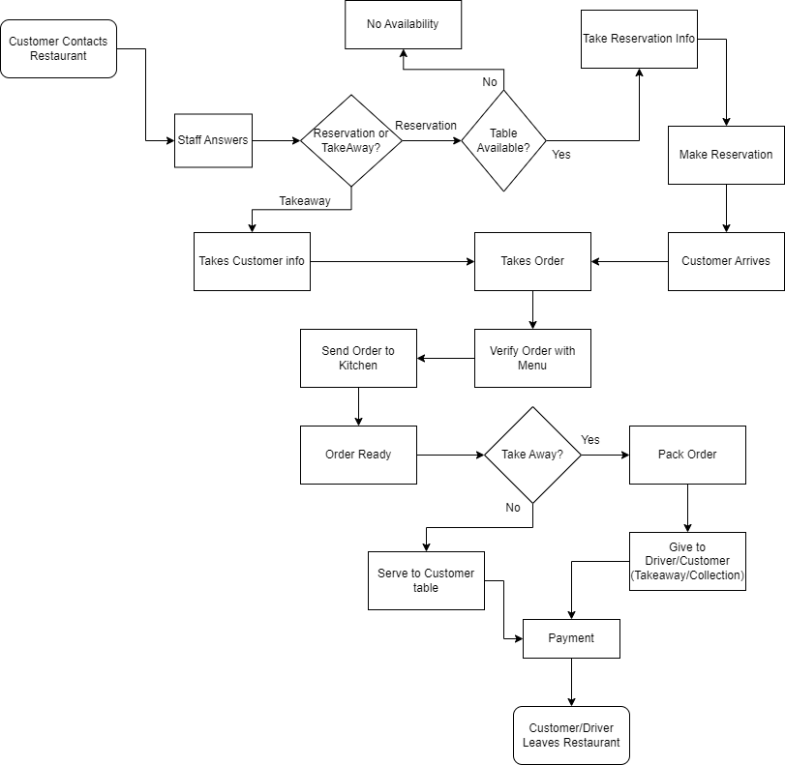

1. **Two Sub-Process Maps Based on the Main Process Map**

* **Payment (Sub-Process #1)**

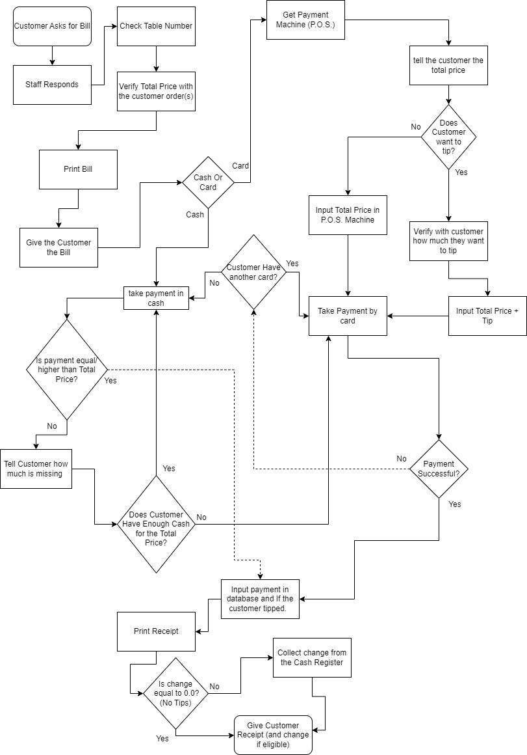

* **TakeAway (Sub-Process #2)**

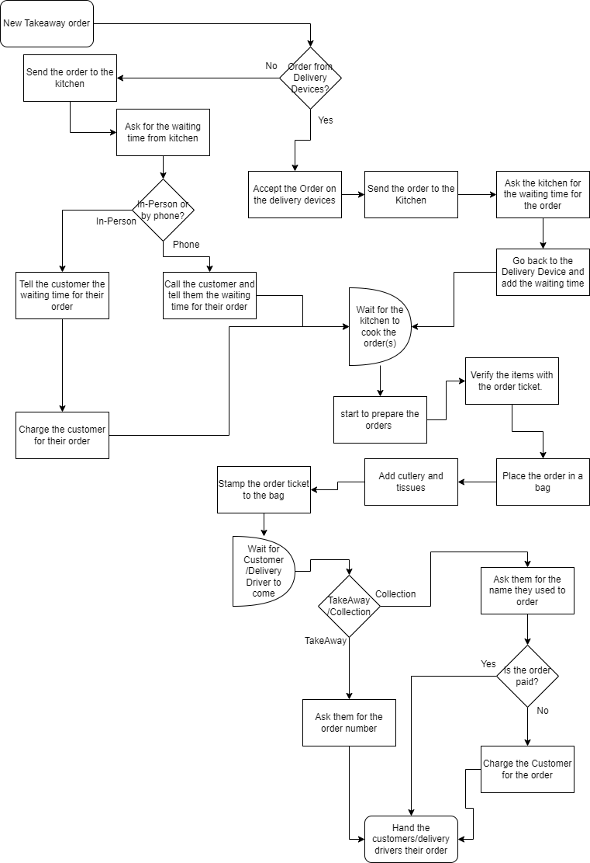

1. **One Cross Functional (Swimlane) Diagram based on main process map.**

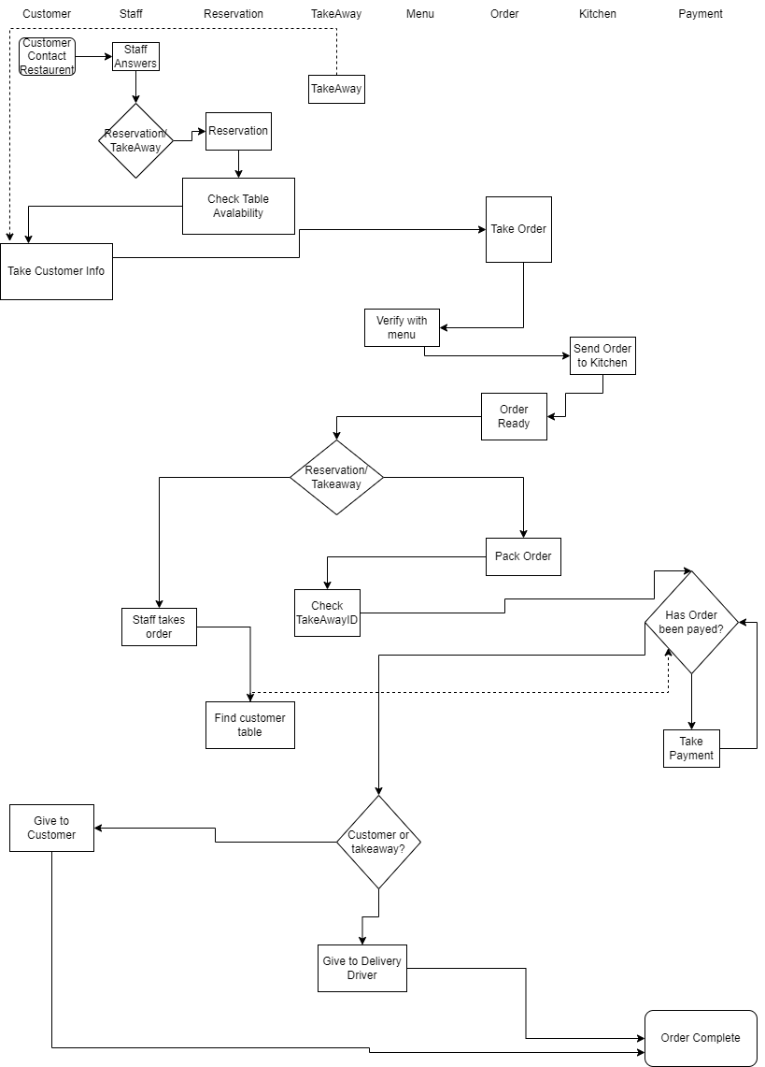

**Critical Success Factors:**

1. **Customer Satisfaction**: To be successful, businesses need to make sure they are meeting the needs and expectations of their customers. When customers are happy, they are more likely to come back, tell others or advertise us online, and spend more money, which is great for business. That is why making customer satisfaction a top priority in our restaurant and providing excellent customer experience is key to achieving a long-term success.
2. **Quality Product / Service**: It is important to sell only the highest quality products for some businesses, our business model and goal is to be a high-end expensive restaurant that uses only the best ingredients to make traditional Japanese cuisine. We must maintain our quality ingredients and food as it is a critical success factor for our restaurant, not to mention Quality service as well.
3. **Menu Variety**: We are a Japanese restaurant, however, we have meat and seafood dishes, as well as rolls, sushi, nigiri, Ramen, katsu, curry and many more, we also have French cuisine and Italian cuisine style food in our restaurant, which creates a wide variety of what to eat and enjoy.
4. **Location**: Our location is a critical success factor for our restaurant, as our restaurant is Infront of the sea, at Dun Laoghaire, and Dun Laoghaire known to be a lavish spot in Ireland. We have an amazing food from our restaurant with amazing décor and perfect positioning which hugely helps our restaurant.
5. **Employee training and development:** We train our employees, so they improve and provide only the best quality service, to be consistent and be efficient, while maintaining a high standard of quality to build the restaurants reputation as they represent it as servers. As for the cooks to learn how to cook using the best quality ingredients from all over Japan, to have teamwork and maintain quality in their cooking, in both taste and appearance.

**Data Dictionary (Excluded word count)**

1. **Customer**

|  |  |
| --- | --- |
| CustomerID | PK |
| Firstname | Short text (10) |
| Surname | Short text (10) |
| Phone-number | Short text (15) |
| Email | Short text (15) |

1. **Staff**

|  |  |
| --- | --- |
| StaffID | PK |
| Firstname | Short text (10) |
| Surname | Short text (10) |
| Job-Role | Short text (10) |
| PhoneNumber | Short text (20) |
| PPSN | Short text (15) |
| Address | Long text (20) |
| Schedule | Date/Time |

1. **TakeAway**

|  |  |
| --- | --- |
| TakeawayID | PK |
| Address | Long text (30) |
| CustomerID | FK |
| Date of Takeaway | Date/Time |
| Time of Takeaway | Date/Time |

1. **Reservation**

|  |  |
| --- | --- |
| ReservationID | PK |
| CustomerID | FK |
| No-of-people | number |
| Table | number |
| Date of Arrival | Date/Time |
| Time of Arrival | Date/Time |

1. **Menu**

|  |  |
| --- | --- |
| MenuID | PK |
| Foodname | ShortText(20) |
| Price | Currency |

1. **Payment**

|  |  |
| --- | --- |
| TransactionID | PK |
| CustomerID | FK |
| OrderID | FK |
| StaffID | FK |
| PaymentType | ShortText(20) |
| Status of Payment | ShortText(20) |
| TotalPrice | Currency |
| TotalPaid | Currency |
| Change | Currency |
| Tips | Yes/No |

1. **Order**

|  |  |
| --- | --- |
| OrderID | PK |
| CustomerID | FK |
| FoodnameID | ShortText(20) [From Menu] |
| Quantity | Number |
| TotalPrice | Currency |

1. **Kitchen**

|  |  |
| --- | --- |
| KitchenID | PK |
| OrderID | FK |
| CustomerID | FK |
| FoodName | ShortText(20) |
| Quantity | Currency |

Reference list:

Indeed Editorial Team (2023). *How To Manage Restaurant Staff Successfully*. [online] Indeed. Available at: https://www.indeed.com/career-advice/career-development/how-to-manage-restaurant-staff [Accessed 11 Mar. 2023].

Khatiri, S. (2019). *5 tips to understand (and organize) your restaurant data*. [online] Klipfolio.com. Available at: https://www.klipfolio.com/blog/tips-to-manage-restaurant-data [Accessed 10 Mar. 2023].

Kuligowski, K. (2023). *Small Business Guide to a Restaurant Management System*. [online] business.com. Available at: https://www.business.com/articles/restaurant-management-system-guide/ [Accessed 11 Mar. 2023].

Miksen, C. (2011). *Key Elements of a Successful Restaurant*. [online] Chron.com. Available at: https://smallbusiness.chron.com/key-elements-successful-restaurant-25545.html [Accessed 11 Mar. 2023].

Norton, E. (2021). *The ultimate guide to restaurant data and analytics*. [online] blog.gotenzo.com. Available at: https://blog.gotenzo.com/the-ultimate-guide-to-restaurant-data-and-analytics [Accessed 10 Mar. 2023].

PopMenu (n.d.). *Restaurant Analytics: How to Collect (and Use) Guest Data*. [online] get.popmenu.com. Available at: https://get.popmenu.com/blog/restaurant-analytics-data-guide [Accessed 11 Mar. 2023].

Sling (2019). *10 Types Of Restaurants: The Complete Guide For Potential Owners*. [online] Sling. Available at: https://getsling.com/blog/types-of-restaurants/ [Accessed 10 Mar. 2023].

The Restaurant Times (2016). *9 Key Elements Of A Successful Restaurant Business*. [online] The Restaurant Times. Available at: https://www.posist.com/restaurant-times/restro-gyaan/9-essential-traits-successful-restaurant.html [Accessed 11 Mar. 2023].